Country Summary: New Zealand

Photo: MurielBendel, CC BY-SA 4.0, via Wikimedia Commons
Executive summary of the New Zealand country profile (2026-10-21). Superscript numbers refer to the numbered sources in New Zealand_Profile_DRAFT_SOURCES.docx.

At a Glance

5.36 m  Population, 30 June 2026, provisional³ | 57,350  GDP per capita, PPP (international dollars), about, 2025⁶ | 10.06%  Current health expenditure, share of GDP, 2024³⁷ | 12.7%  Out-of-pocket share of current health expenditure, 2024³⁹
3.61  Physicians per 1,000 people, 2022⁴³ | 82.0  Life expectancy at birth, years, 2024¹⁴ | 17.6%  Population aged 65 and over, 2025¹² | NZ$34.2 bn  Total health spending, 2026/27, government figure¹⁹
Country background
New Zealand, a constitutional monarchy with its capital in Wellington, had about 5.36 million people at 30 June 2026 (provisional).^{1,3,7} Governor-General Dame Cindy Kiro represents the King, and Prime Minister Christopher Luxon leads a National, ACT and New Zealand First government.^{8,9} Simeon Brown is Minister of Health, and Health New Zealand has delivered public services nationally since 2022.^{16,19} The high-income economy grew 1.7 percent in the year ended June 2026, and GDP per person was about 57,350 international dollars (PPP) in 2025.^{6,20} The population is aging: 17.6 percent were 65 or older in 2025, and life expectancy was 82.0 years in 2024.^{12,14} The key risk is fiscal, because the Treasury warns that demographic change, unless checked, will make the long-term fiscal position unsustainable.²¹
Key takeaways for CSI
- Health spending reached 10.1 percent of GDP in 2024, from 9.2 percent in 2012.³⁷
- International graduates were 43.5 percent of registered doctors in 2025, but only 40 percent stay two years.⁴²
- In 2024/25, 34.2 percent of adults were obese and 14.3 percent reported high or very high psychological distress.²⁶
- In 2026 Health New Zealand signed its first long-term private hospital contracts, worth about $300 million.³⁶

Health System

- Health New Zealand replaced the district health boards in 2022 and delivers tax-funded universal care nationally.¹⁶
- Elective treatment within four months reached 72.6 percent in 2025/26, up from 63.9 percent.³⁰
- In 2024/25, cost stopped 14.9 percent of adults visiting a GP, and 25.5 percent cited appointment waits.²⁶
New Zealand: health spending and out-of-pocket share, 2012 to 2024
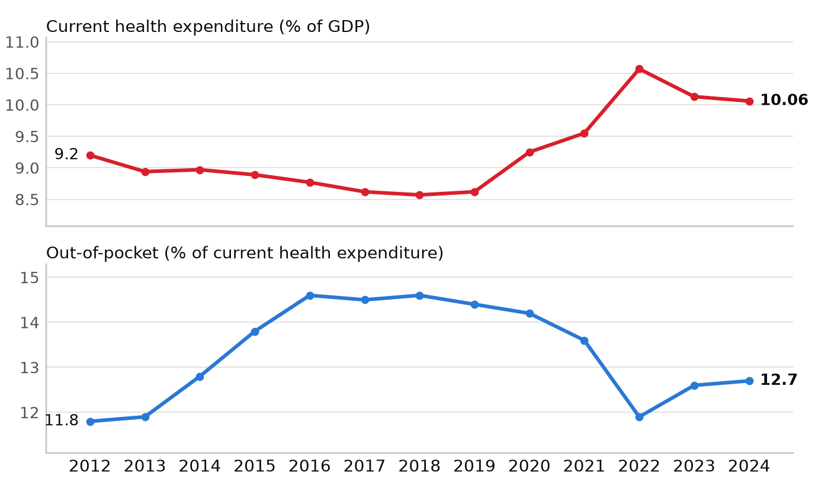
Current health expenditure as a share of GDP, and out-of-pocket spending as a share of current health expenditure. Sources: ^{37,39}
Physicians per 1,000 people, New Zealand and comparators (latest year available)
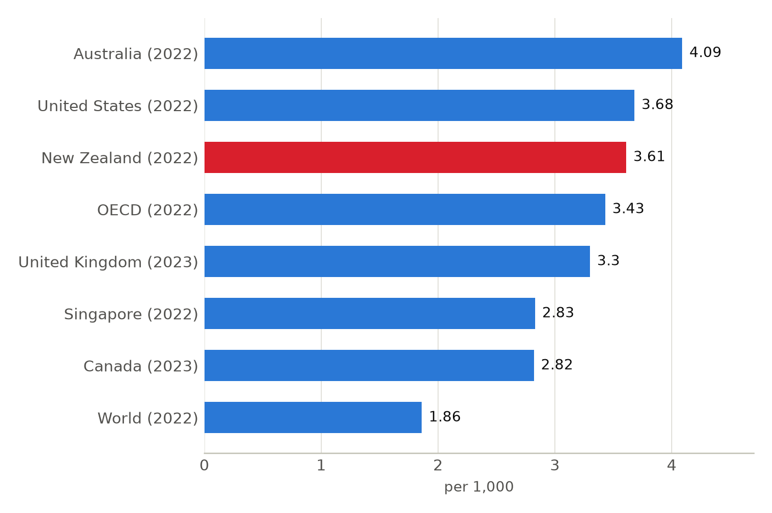
Latest year available for each country in the World Bank series, shown in brackets; comparison years differ (2022 and 2023). Sources: ⁴⁷

Market and Competition

- About 37 percent of people hold private insurance, and Southern Cross has about 60 percent of the market.^{16,31}
- Icon Oncology Group runs Wellington's Bowen Icon Cancer Centre with Australian-owned Evolution Healthcare.^{34,53}
- Health New Zealand signed a digital and AI innovation agreement with London's UCLPartners in July 2026.⁵⁶
New Zealand: hospital beds per 1,000 people, 2012 to 2023
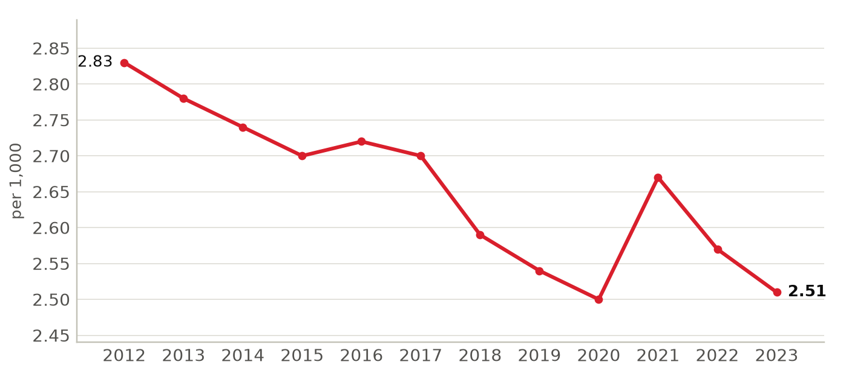
Hospital beds as reported to the World Bank; 2023 is the latest year in the series. Sources: ⁴⁶
Foreign health systems active in New Zealand
8 foreign institutions with confirmed active partnerships (8 in all): 4 research collaboration, 2 training and education, 1 ownership or management, 1 advisory and consulting. Sources in the profile and the partnerships tracker.
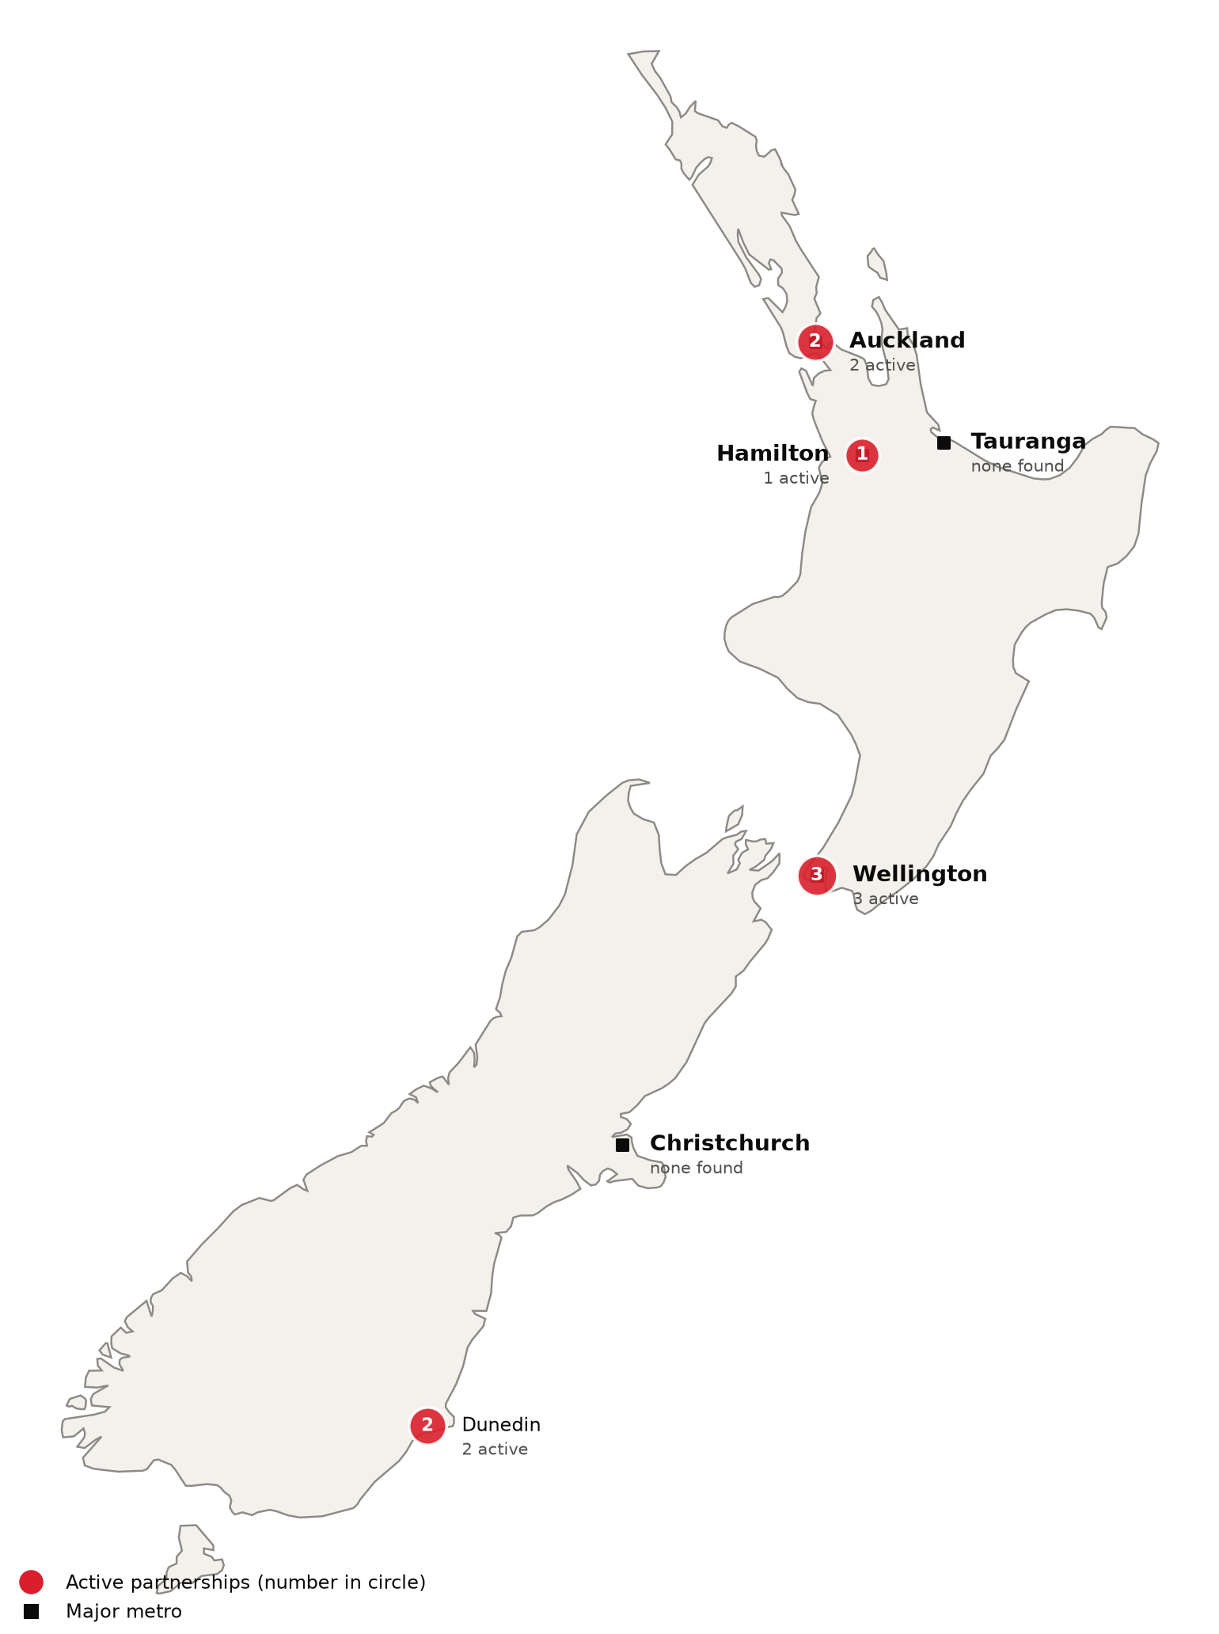
Active foreign health-system partnerships by city of the partner in New Zealand. Source: CSI partnerships tracker, verified 2026-10-21. Boundaries: Natural Earth; not an official depiction.
Institution | Nature of collaboration
Johns Hopkins University (Bloomberg School of Public Health, Center for Indigenous Health) | Research collaboration
Icon Oncology Group (Icon Group) | Ownership or management
National University of Singapore and National University Health System | Research collaboration
UCLPartners | Advisory and consulting
Universitas Indonesia (Faculty of Public Health) | Training and education
University of Southampton (MRC Lifecourse Epidemiology Centre, EpiGen Global Research Consortium) | Research collaboration
University of Wollongong (Graduate School of Medicine) | Training and education
West Visayas State University | Research collaboration

CSI Position, Risks and Recent News

CSI partnerships in New Zealand
[MANUAL INPUT REQUIRED]
To be completed by CSI from internal data; not researched.
Opportunities for CSI
[MANUAL INPUT REQUIRED]
To be completed by CSI from internal data; not researched.
Risks and watch items
- A general election is due on 7 November 2026.⁹ Its result will shape private outsourcing of elective surgery.
- The Treasury expects superannuation and finance costs to take about 28 percent of tax revenue by 2030/31.²¹
- Practicing nurses fell 4 percent to 80,960 at 30 June 2026, and 43.5 percent qualified overseas.⁴⁵
Recent developments
2026-04-16 Mark Darrow became Health New Zealand board chair on 1 May 2026 for three years, replacing Lester Levy.²⁸
2026-05-28 Budget 2026 added more than $5.8 billion in new health operating funding, including a $1.37 billion annual uplift.¹⁹
2026-10 Health New Zealand reported 87.0 percent of cancer patients treated within 31 days of the treatment decision in 2025/26.³⁰

